Databases JDBC Project  
Christopher Connolly A00247198

18/11/2016  
  
  
  
Key Concept:  
I wanted to do a database with a large number of datapoints. As such I found the preliminary population data from the 2016 Irish census from the Irish government’s Open Data website at data.gov.ie.   
  
The information came as a CSV file, and I used Excel to tidy the information up to be easier to put into a database. This involved taking out electoral district numeric identifier and apostophes (such as in St.Kevin’s, which interfered with SQL formatting) using excel functions, then putting the raw data into rows using an excel formula to order the data into SQL format. Then I copied and pasted this data into a plain text file and finished the SQL by hand.

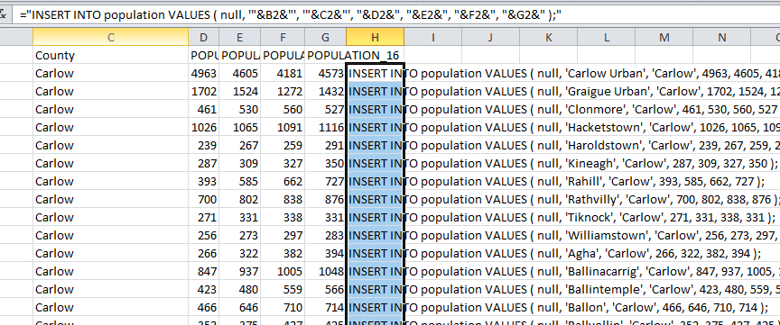  
The data creates 3407 rows and takes a few seconds (~30) to insert.

Then I began a new Java program in Netbeans, referencing the external library MySqlConnector, which was passed in as a jar file in the build path.

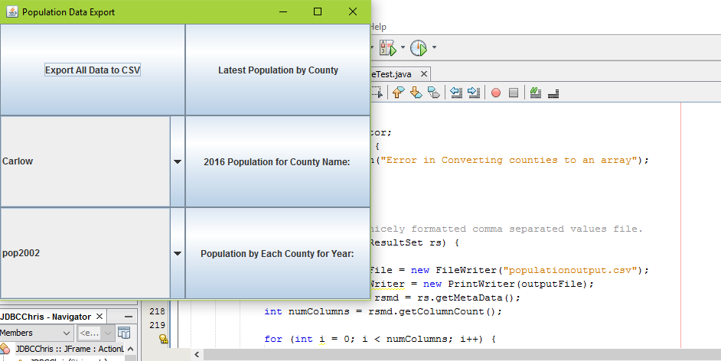

The program allows a user to export all census data, census data per county for 2016, census data per year for all counties, or census data per county for all years.   
  
When run the program scans the database in order to populate the County and Year fields. The information is put into an array, and the program then only allows selection of County and Year by means of combination boxes implemented with JComboBoxes. This is safer as raw SQL cannot easily be input into the program by a user, preventing SQL injection type attacks.  
  
All information requested is output to CSV file, as well as to Standard Output (console) for debugging purposes.  
  
The program works well, providing output of data in a reasonable time frame (<20 seconds).